INTRODUCTION TO COMPUTER PROGRAMMING

ASSIGNMENT-3 

Tamanna Gupta

Branch: Electrical

SID: 23104079

Submitted To: Professor Nitin Kumar

Dated: 7-10-2023

output:

Python program:

:

1. Write a python program to print out all Armstrong numbers between 1 and 500.

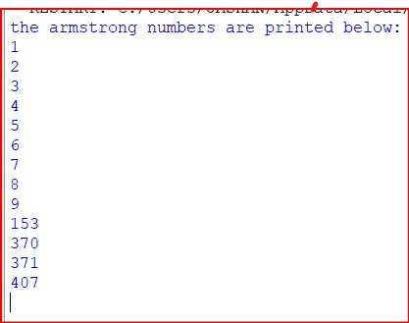

2. Write a python program to find the range of a set of numbers.

Python program:

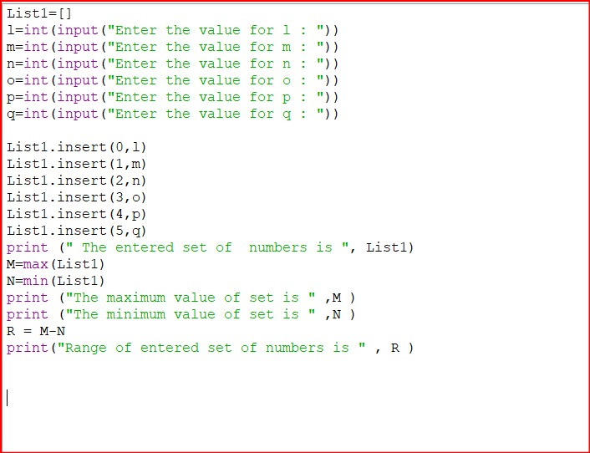

Output:

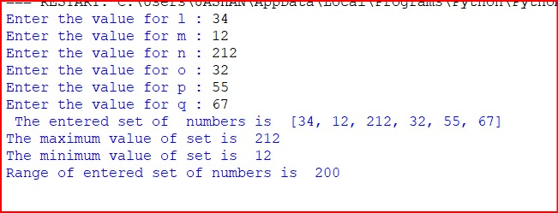

list 1: [10,20,30,40]

3. write a program to iterate both lists simultaneously and display items from list 1 in original order and items from list 2 in reverse order.

list 2: [100,200,300,400]

python program:

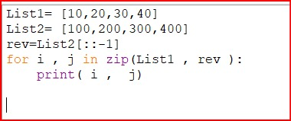

Output:

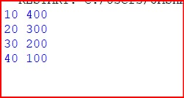

4. Write a program to convert a tuple to a string.

Python program:

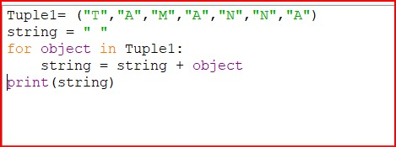

Output:

5. write a Python program to print the following pattern.

A

A B C

A B C D E

A B C D E F G

Python program:

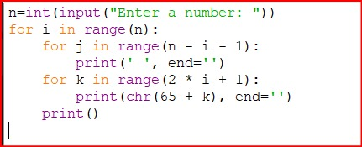

Output:

\*\*\*\*\*

6. Write a python program to print the following pattern.

\*\*\*\*

\*\*\*

\*\*

\*

Python program:

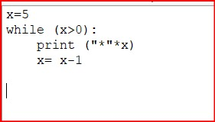

Output:

7. Write a Python program to check whether the number is a perfect number or not .

Output:

8. Write a python program to check whether the number is a palindrome or not.

Output:

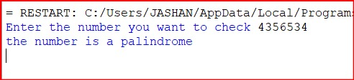

END OF THE ASSIGNMENT!

THANK YOU!